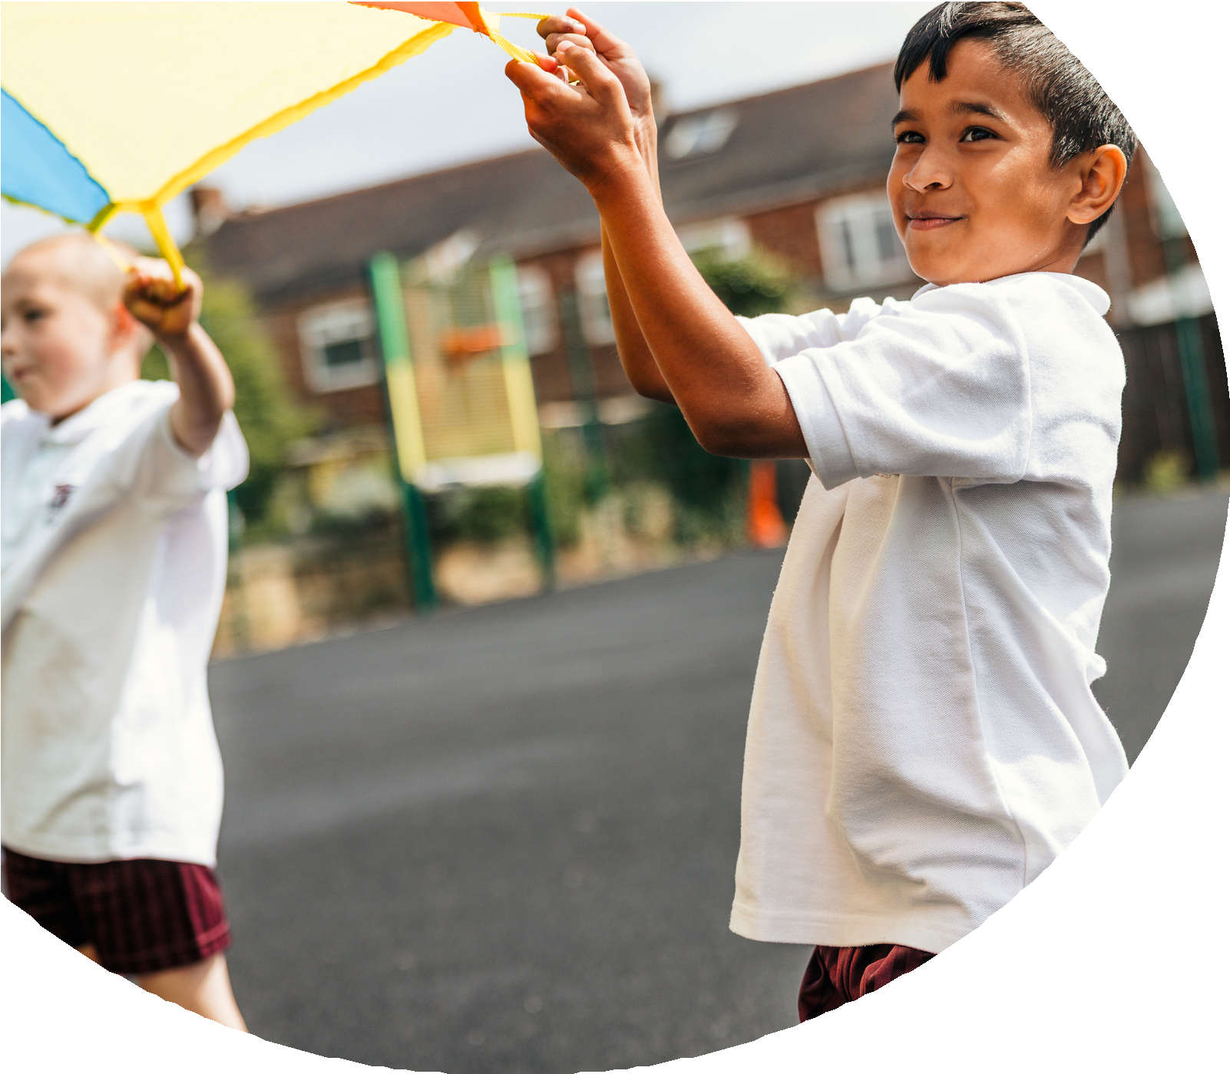
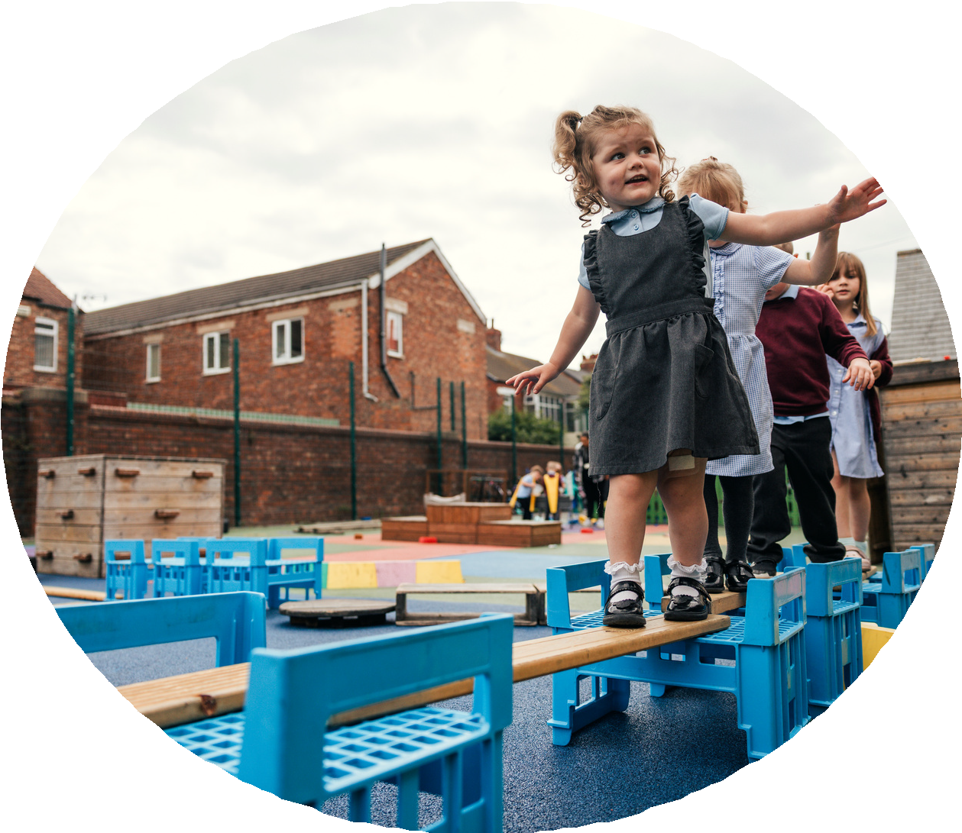

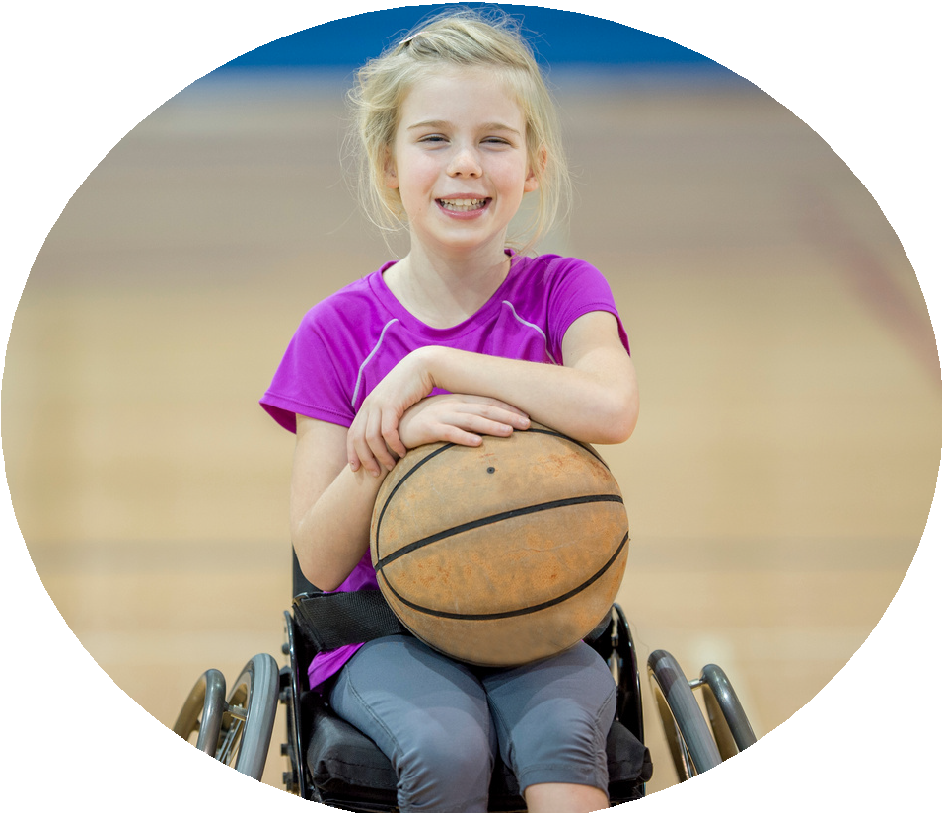



PE and sport premium monitoring and tracking form 2025/2026

Commissioned by

Created by


PE and sport premium monitoring and tracking form
- It is intended that this template should be used as preparation for the completion of the statutory DfE PE and sport premium digital expenditure reporting return. You can upload data (including swimming) from this template onto this platform once it becomes accessible.
- The template is a working document that you can amend and update during the year.
- Before you decide how you are going to use the funding for this academic year you should reflect and evaluate the impact of your use of you PE and sport premium funding in 2024/25.
- You should use your evaluation of last year’s funding to help you decide what to do this academic year, how you will do it, and what impact you expect it to have.
- All spending of the funding must conform with the terms outlined in the conditions of grant
- The summative digital expenditure reporting from June 2026 will continue to include swimming and water safety information. PE and sport premium funding can be used to provide top-up lessons, where necessary, to ensure pupils meet national curriculum swimming requirements
- To ensure funding is used effectively and based on your school’s needs; guidance and examples of best practice across schools can be found here.
- You must use the funding to make additional and sustainable improvements to the PE and sport in your school.
- You must develop and add to the PESSPA activities that your school already offers.

Useful Links:
- PE and sport premium for primary schools - GOV.UK
- PE and sport premium: conditions of grant 2025 to 2026 - GOV.UK
- It is intended that this template should be used as preparation for the completion of the statutory DfE PE and sport premium digital expenditure reporting return. You can upload data (including swimming) from this template onto this platform once it becomes accessible.
- The template is a working document that you can amend and update during the year.
- Before you decide how you are going to use the funding for this academic year you should reflect and evaluate the impact of your use of you PE and sport premium funding in 2024/25.
- You should use your evaluation of last year’s funding to help you decide what to do this academic year, how you will do it, and what impact you expect it to have.
- All spending of the funding must conform with the terms outlined in the conditions of grant
- The summative digital expenditure reporting from June 2026 will continue to include swimming and water safety information. PE and sport premium funding can be used to provide top-up lessons, where necessary, to ensure pupils meet national curriculum swimming requirements
- To ensure funding is used effectively and based on your school’s needs; guidance and examples of best practice across schools can be found here.
- You must use the funding to make additional and sustainable improvements to the PE and sport in your school.
- You must develop and add to the PESSPA activities that your school already offers.

Useful Links:
Complete the PE and sport premium expenditure reporting return - GOV.UK
PE and sport premium for primary schools - GOV.UK
PE and sport premium: conditions of grant 2024 to 2025 - GOV.UK

Review of the last academic year (2024/2025)

Swimming and Water Safety | What went well? Supporting evidence? | What didn't go well? Supporting evidence?
1. Swim competently, confidently and proficiently over a distance of at least 25 metres | Percentage of children in Year 6 who met the requirements for End of Year 6 Swimming: 91%.  Evidenced on Complete PE Swimming assessment tracker based on information and data collected poolside with swimming teacher. We worked with the child, the family, SEND coordinator, attendance support officer and Mental Health Lead to work towards improving the child’s skills and ability. | One child did not meet the requirements.  We want 100% of the children to meet the requirements.  Evidenced on Complete PE Swimming assessment tracker based on information and data collected poolside with swimming teacher.
2. Use a range of strokes effectively (for example, front crawl, backstroke and breaststroke) | Percentage of children in Year 6 who met the requirements for End of Year 6 Swimming: 91%.  Evidenced on Complete PE Swimming assessment tracker based on information and data collected poolside with swimming teacher. We worked with the child, the family, SEND coordinator, attendance support officer and Mental Health Lead to work towards improving the child’s skills and ability. | One child did not meet the requirements.  We want 100% of the children to meet the requirements.  Evidenced on Complete PE Swimming assessment tracker based on information and data collected poolside with swimming teacher.
3. Perform safe self-rescue in different water-based situations | Percentage of children in Year 6 who met the requirements for End of Year 6 Swimming: 91%.  Evidenced on Complete PE Swimming assessment tracker based on information and data collected poolside with swimming teacher. We worked with the child, the family, SEND coordinator, attendance support officer and Mental Health Lead to work towards improving the child’s skills and ability. | One child did not meet the requirements.  We want 100% of the children to meet the requirements.  Evidenced on Complete PE Swimming assessment tracker based on information and data collected poolside with swimming teacher.
- Take some time to reflect on your intent, implementation and impact from last academic year to celebrate your wins but to also think about improvements for the year ahead.
- You do not need to complete every box. Just record the information that is key to your school's priorities and areas of focus.
Remember - Be clear about how you focussed spending on key groups such as SEND, girls and disadvantaged pupils.

Review of the last academic year (2024/2025)
Key areas as outlined in PE and sport premium guidance | What went well? Supporting evidence? | What didn't go well? Supporting evidence?
1. Increasing confidence, knowledge and skills of all staff in teaching PE and sporting activities prioritising CPD and training where needed | A robust CPD program resulted in an increase in staff confidence, particularly in teaching dance and how to use dance to enhance learning in Maths and English to increase the number of active minutes of learning for the children each day. As a result of a clear focus on teacher CPD and a new curriculum implemented, pupil attainment data rose. It’s great that staff now feel confident to enjoy delivering high quality Physical Education including teaching assistants who took part in the sessions with the children in the Team Teach sessions with Blue Moose Dance Company. Lesson Observations and walkthroughs on the Monitoring Form. iscussion and reports for Creative Team governor. Evidence in planning. Portals Usage. Recording Sheets in Planning Folders. Percentage of children who meet expectations.  PE Passport App training – multiple sessions for JB – Phone calls and training online. Discussed how the app constrains us and this has been fed back to the team who produce it and certain improvements put in place so we will be able to get the best out of it in the future. Training was disseminated in school to all teachers and teaching assistants so we can all make best use of the money spent on this resource. Sustainable through continuous funding  Staff supported in their CPD with Dance, Orienteering, Cricket, Football, Rugby, Dodgeball and Gymnastics and talked about using in lessons. Sustainable through Orienteering online portal, LHSSN for next year (Rugby, Cricket, Dodgeball, football), Dance sustainable through Head to Toe plans left, Gymnastics through purchase of PE Passport bolt on again and through priorities already identified for next year.  - Orienteering training for all teaching staff – full day  - Y2/3 – Dodgeball session – Lancaster and Heysham School Sports Partnership session in school including staff training  - 4.11 - Teaching Gymnastics Training – JB training from ex-Britiish gymnast  - 5.12 – PE Cluster Meeting - Balmoral Road PE Cluster meeting – Fed back to staff at meeting. This was well timed as there had been other guidance to clarify what the Sports’ Premium could be spent on. This meant we changed our priorities for the year again. Sustainable through local schools cluster bought into  - 20.12 – Blue Moose Dance Inset – Full Day Teaching Staff  - 16.1 – Breakfast Briefing PE Funding Changes with Head teacher and Creative TEAM Governor  - Weekly Blue Moose PE Dance lessons (12 weeks) (R-Y6)  - Weekly Blue Moose English Dance lessons (3 weeks) Y2-6 – Team Teaching with MO and JB  - Weekly Blue Moose Maths Dance lessons (3 weeks) Y2-6 – Team Teaching with MO and JB  - Mental Health Awareness Training for Mental Health Children’s Champions within school through Lancaster and Heysham School Sports Partnership including one staff member trained  - 27.3 Online Questions and Answer session with Max Whitlock Y2/3 through PE Passport Gymnastics Bolt on – Ex Olympic/British/World Champion  - Support Staff meeting – PE Passport App Assessment training session  - Lancashire Cricket Sessions for Y6/2/3 - Support and training for MO and JB  - Wigan Warriors Rugby sessions with Y2/3/4/5/6 Support and training for MO and JB  - Y4/5 Young Leaders’ and Play leaders Award through LHSSN  - 15.5 Y2-6 sessions with Lancashire Cricket Team through LHSSN  - PE Sports Funding documentation completion session | It’s great that all staff who were part of the programme for Dance now feel confident to enjoy delivering high quality Dance but we need this to apply to staff who did not work on the Friday delivery sessions.
2. Increasing engagement of all pupils in regular physical activity and sporting activities | Additional opportunities for all pupils to engage in physical activity at lunchtimes and breaktimes.  100% of pupils have been active in through Enrichment activities with Garstang School Sports Partnership and Lancaster and Heysham School Sports Network.  TA training session on 60 active minutes a day linked to play leaders – Play leaders are now supported by staff on duty to access the equipment daily and support the other children to be active at lunchtimes. This linked well with the Play Leaders training for Year 5 as they will now take over the responsibility to deliver this requirement. Sustainable through LHSSN and equipment purchases to extend and replace broken equipment  Play leaders keen and eager to take on roles and responsibilities with younger children keeping themselves and others active. This has been extended to Y4 and Y5 this year as the number of children in each year group necessitated this. This will continue in future year groups as this ensures update training and support for children who are new to the role providing succession planning and sustainability through LHSSN. | Not all pupils are active for 60 minutes a day 7 days a week. We have no data to back up activities outside of school.  More KS1 and EYFS clubs needed. After School clubs are generally offered to KS2. Clubs to be offered at lunchtimes next year.
3. Raising the profile of PE and sport across the school, to support whole school improvement | By celebrating PE in worships and activities they have undertaken with the Sports Partnerships as well as sporting accolades outside of school, we are encouraging more pupils to enjoy movement and physical activity.  100% of pupils will be developed in their physical, cognitive, social and emotional learning, therefore improving attainment data in PE and across the school.  Pupils are inspired to be more active, therefore supporting the target for all pupils to be active on average 60 minutes a day, 7 days a week.  1xTA trained on mental Health lead alongside children – Mental Health children’s group to be set up next year in association with the mental health lead and should funding allow us to access the LHSSN these children will continue to be trained through this process to support their peers in school. Sustainable through LHSSN. 60 active minutes achieved for children daily. Sustainable through timetable and LHSSN training for children and staff.  Mental health impacts on children who have participated – increased confidence to try new things, wanting to participate, wanting to keep fit, asking when sessions are.  Challenging curriculum targets for children. Sustainable through PE Passport APP Curriculum. Curriculum adaptation for younger and older year groups as appropriate linked to units for the half term. Adaptations made for children with SEND. Sustainable through PE Passport APP Curriculum.  Adaptations made for children with skills supported by learning and clubs outside of school. Sustainable through Swimming sessions, curriculum, gymnastics training and opportunities through LHSSN and GSSP. | Not all pupils are active for 60 minutes a day 7 days a week.
4. Offer a broader and more equal experience of a range of sports and physical activities to all pupils and ensure equal access to sport for boys and girls | Continuing to offer a wider range of activities both within and outside the curriculum in order to get more pupils involved:  Extra-curricular – Dodgeball, Dance, Cheerleading, Netball, Football, Girls Football, Yoga.  Focus particularly on encouraging those pupils who do not take up additional PE and Sport opportunities after school to be included/chosen to participate in events in school time.  Regular sporting events for the children to attend linked to sport outside school time as well as 2 hours of PE sessions in school every week. Sustainable through curriculum time and GSSP  Children experience a wider range of sports. | Not all pupils are active for 60 minutes a day 7 days a week.  A limited number of FS/KS1 attended extra-curricular clubs at school.  Next year plans include gymnastics, ballet, Olympics, climbing wall
5. Increasing participation in competitive sport | 100% of FS/KS1 and 100% of KS2 have taken part in an Inter House competition.  100% of KS2 have taken part in extra curricular competitions. | Continue to develop our competition provision and monitor the engagement of groups in these activities.

Aims for the next academic year (2025/2026)
- Using your whole school priorities, school development plan and previous PE, school sport and physical activity data, set out your aims for the year ahead.
- Think about specific areas of need such as inactive girls, SEND and disadvantaged pupils
- Remember to also input your swimming data and reflections in the table located at the bottom of this page.
- Consider which of the 5 key areas improvements will be focussing on:
- Increasing confidence, knowledge and skills of all staff in teaching PE and sporting activities prioritising CPD and training where needed.
- Increasing engagement of all pupils in regular physical activity and sporting activities
- Raising the profile of PE and sport across the school, to support whole school improvement
- Offer a broader and more equal experience of a range of sports and physical activities to all pupils and ensure equal access to sport for boys and girls
- Increasing participation in competitive sport
Swimming and Water Safety | Input data | Reflections
1. Swim competently, confidently and proficiently over a distance  of at least 25 metres | At the end of Year 5 ??% of children could could swim 25m. | Top up swimming necessary following a baseline assessment of year 6 to check if the data is still accurate in year 6.
2. Use a range of strokes effectively  (for example, front crawl, backstroke and breaststroke) | At the end of Year 5 ??% of children could could swim 25m. | Top up swimming necessary following a baseline assessment of year 6 to check if the data is still accurate in year 6.
3. Perform safe self-rescue in different water-based situations | At the end of Year 5 ??% of children could could swim 25m. | Top up swimming necessary following a baseline assessment of year 6 to check if the data is still accurate in year 6.

Aim | Why? | Key area | Supporting evidence
£295 - Gymnastics inset (double checking on cost)  £1710 - Gymnastics 12 x 3hrs Fridays Spring Term (double checking on cost) | Staff have identified Gymnastics as the next area of PE where confidence is not as high as other areas. | Increasing confidence, knowledge and skills of all staff in teaching PE and sporting activities prioritising CPD and training where needed. | Staff confidence surveys, pupils attainment data, lesson observation reviews, pupil voice.
Focus on teacher training ensuring all teachers are confident to enjoy teaching High Quality Physical Education.  Including £10 - Rounders training  £?? Swimming training SW, MO, JB  £?? Swimming training for KH, CC, DG, CP, WM | To ensure all children are participating in two hours a week of high-quality PE every week. | Increasing confidence, knowledge and skills of all staff in teaching PE and sporting activities prioritising CPD and training where needed. | Staff confidence surveys, pupils attainment data, lesson observation reviews, pupil voice.
Provide in school opportunities for pupils to access multiple opportunities to be physically active and monitor external physical activity to drive physical activity levels with key focus groups.  £700 - PE Passport App | To ensure that all pupils will be active on average 60 minutes a day, 7 days a week. | Increasing engagement of all pupils in regular physical activity and sporting activities | External physical activity trackers outlining the amount of activity pupils’ access outside of school.  Extra curricular timetable and participation data.  Lunchtime participation data, alongside lunchtime activity plan.  Data for all physical activity level tracked on PE Passport APP assessment.
£500 - Cross Curricular Orienterring Curriculum use and more access to lunchtime and break | To ensure that all pupils will be active on average 60 minutes a day, 7 days a week.  To ensure all children are participating in two hours a week of high-quality PE every week. | Increasing engagement of all pupils in regular physical activity and sporting activities  Increasing confidence, knowledge and skills of all staff in teaching PE and sporting activities prioritising CPD and training where needed. | External physical activity trackers outlining the amount of activity pupils’ access outside of school.  Extra curricular timetable and participation data.  Lunchtime participation data, alongside lunchtime activity plan.  Data for all physical activity level tracked on PE Passport APP assessment.
£2990 - Autumn Swimming  £2350 - Swimming Spring  £2780 - Swimming Summer | To ensure that all pupils will be active on average 60 minutes a day, 7 days a week.  To ensure all children are participating in two hours a week of high-quality PE every week. | Increasing engagement of all pupils in regular physical activity and sporting activities  Increasing confidence, knowledge and skills of all staff in teaching PE and sporting activities prioritising CPD and training where needed. | External physical activity trackers outlining the amount of activity pupils’ access outside of school.  Extra curricular timetable and participation data.  Lunchtime participation data, alongside lunchtime activity plan.  Data for all physical activity level tracked on PE Passport APP assessment.
School Sports Networks  £1300 - GCA  £2195 - LHSSN | To ensure all pupils can access competition in school and outside of school, to encourage all pupils to participate and enjoy these valuable experiences. | Increasing participation in competitive sport | Competition formats and planning for all intra lesson level competitions, all inter competitions hosted at our school and sports day.  Virtual multi skills league format and results.  Competition calendar and register of participants.

Singspiration
Aims for the next academic year (2025/2026)

Plan, monitor and evaluate (2025/2026)
- Please aim to use this as a live working document through the year.

- Keep returning to this to evidence adaptations and progress made through the PESSPA opportunities you provide.

- There is no set number of objectives you must have.

- Make as many or as few as you see fit that will support your aims for the year ahead.

- Consider which of the 5 key areas improvements will be focussing on:
- Increasing confidence, knowledge and skills of all staff in teaching PE and sporting activities prioritising CPD and training where needed.
- Increasing engagement of all pupils in regular physical activity and sporting activities
- Raising the profile of PE and sport across the school, to support whole school improvement
- Offer a broader and more equal experience of a range of sports and physical activities to all pupils and ensure equal access to sport for boys and girls
- Increasing participation in competitive sport

Plan, monitor and evaluate (2025/2026)

Example objective shown below is for reference purposes only:
 | Intent – what is your objective? | Implementation - How will you achieve this? | Impact - What do you hope to see? | Supporting evidence
Plan and monitor | Develop lunchtime play provision to increase activity for least active groups. | Develop pupil leadership (training programme), Midday supervisor training, Staff CDP to develop their understanding of games and play, Range of equipment, Youth voice activities to understand pupils wants and needs Outdoor play provision such as OPAL | A confident and competent group of activity leaders that take initiative and create a more active and inclusive playground for all pupils. Midday supervisors and all staff leading a range of physical activities and joining in with movement daily to role model. A happier, more active playground that meets the needs of all pupils especially SEND and girls. | Youth voice data through half-termly surveys and interviews/group discussions with a variety of pupils (leaders, children participating and those that are less active at break times). Conduct regular observations of the playground to gauge activity levels of the least active children. Staff voice and feedback
 | What impact have you seen? | Are the improvements sustainable? How? | Supporting evidence | Approx. cost
Evaluate | Activity leaders are leading a broad range of activities and actively seeking children that are not engaged in physical activity during lunch times. Midday supervisors have grown in confidence and far more active and engaged in games with the children. Lunch times are more active with children having fun. Activity options have been tailored to suit the needs of SEND pupils through considerate choices of equipment and the types of games played. Girls are proving to be the hardest group to engage as some are still choosing not to be active | Continued training for activity leaders and bringing new leaders into the group to bring new ideas and expertise. More leaders will also mean more activities are able to be delivered. Continued training with midday supervisors. Establish lead midday supervisors to empower them and give them ownership. Continue to listen to SEND pupils and tailor activities to their needs and wants. Focus priorities on engaging girls. Work with least active girls to create activities that are meaningful and enjoyable for them. Do they want to be activity leaders for younger children to give them purpose and confidence? | 100 out of 100 activity leaders want to carry on with this role next year. 30 more children have enquired to joining the team. Meetings and the end of year survey have shown all leaders feel positive and enjoy making a difference for others. Interviews by random selection were conducted and 92% of pupils were either 'happy' or 'very happy' with the activities on offer at lunch time. End of year physical activity survey findings such as:  - Am I involved with games at lunch time - 89% Yes  - Do I enjoy lunch time? 97% Yes  - Have I joined in with a game with the activity leaders? 100% Yes | Physical Resources - £1000  CPD for staff - £500  OPAL - £8000
Your Objective:

 | Intent – what is your objective? | Implementation - How will you achieve this? | Impact - What do you hope to see? | Supporting evidence
Plan and monitor

 | What impact have you seen? | Are the improvements sustainable? How? | Supporting evidence | Approx. cost
Evaluate

Your Objective:

 | Intent – what is your objective? | Implementation - How will you achieve this? | Impact - What do you hope to see? | Supporting evidence
Plan and monitor

 | What impact have you seen? | Are the improvements sustainable? How? | Supporting evidence | Approx. cost
Evaluate

Your Objective:
 | Intent – what is your objective? | Implementation - How will you achieve this? | Impact - What do you hope to see? | Supporting evidence
Plan and monitor

 | What impact have you seen? | Are the improvements sustainable? How? | Supporting evidence | Approx. cost
Evaluate

Your Objective:
 | Intent – what is your objective? | Implementation - How will you achieve this? | Impact - What do you hope to see? | Supporting evidence
Plan and monitor

 | What impact have you seen? | Are the improvements sustainable? How? | Supporting evidence | Approx. cost
Evaluate

Your Objective:

 | Intent – what is your objective? | Implementation - How will you achieve this? | Impact - What do you hope to see? | Supporting evidence
Plan and monitor

 | What impact have you seen? | Are the improvements sustainable? How? | Supporting evidence | Approx. cost
Evaluate

This page has been left blank for any notes or supporting information.

