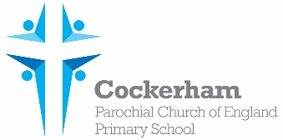

Year One Spellings-week beginning 6th Nov u_e

|  |  |  |  |  |
| --- | --- | --- | --- | --- |
|  | Look | Cover | Write | Check |
| fume |  |  |  |  |
| tube |  |  |  |  |
| rule |  |  |  |  |
| flute |  |  |  |  |
| what |  |  |  |  |

Please practise spelling these words at home. Our spelling test is on Monday 13th Nov.