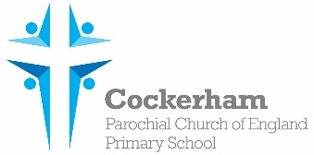Year One Spellings-week beginning 13th May

|  |  |  |  |  |
| --- | --- | --- | --- | --- |
|  | Look | Cover | Write | Check |
| chief |  |  |  |  |
| brief |  |  |  |  |
| field |  |  |  |  |
| shield |  |  |  |  |
| eye |  |  |  |  |

Please practise spelling these words at home. Our spelling test is on Monday 20th May.