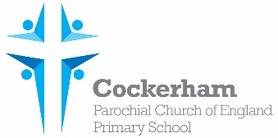

Year One Spellings-week beginning 11th December

|  |  |  |  |  |
| --- | --- | --- | --- | --- |
|  | Look | Cover | Write | Check |
| lion |  |  |  |  |
| wild |  |  |  |  |
| child |  |  |  |  |
| gold |  |  |  |  |
| their |  |  |  |  |

Please practise spelling these words at home. Our spelling test is on Tuesday 19th December.