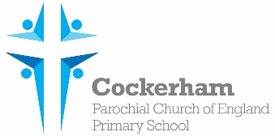Year One Spellings-week beginning 10th June

|  |  |  |  |  |
| --- | --- | --- | --- | --- |
|  | Look | Cover | Write | Check |
| looked |  |  |  |  |
| yelled |  |  |  |  |
| gasped |  |  |  |  |
| painted |  |  |  |  |
| once |  |  |  |  |

Please practise spelling these words at home. Our spelling test is on Monday 17th June.