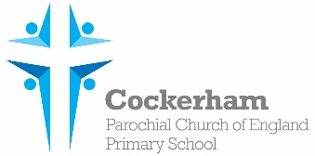Year One Spellings-week beginning 5th February

|  |  |  |  |  |
| --- | --- | --- | --- | --- |
|  | Look | Cover | Write | Check |
| few |  |  |  |  |
| dew |  |  |  |  |
| new |  |  |  |  |
| blew |  |  |  |  |
| asked |  |  |  |  |

Please practise spelling these words at home. Our spelling test is on Monday 19th February.