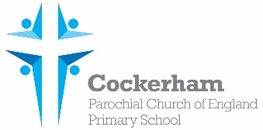Year One Spellings-week beginning 8th December

|  |  |  |  |  |
| --- | --- | --- | --- | --- |
|  | Look | Cover | Write | Check |
| school |  |  |  |  |
| Christmas |  |  |  |  |
| chemist |  |  |  |  |
| echo |  |  |  |  |
| Mrs |  |  |  |  |

Please practise spelling these words at home. Our spelling test is on Monday 15th December.