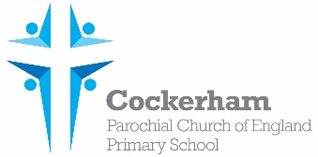Year One Spellings-week beginning 17th June

|  |  |  |  |  |
| --- | --- | --- | --- | --- |
|  | Look | Cover | Write | Check |
| skirts |  |  |  |  |
| goats |  |  |  |  |
| wishes |  |  |  |  |
| boxes |  |  |  |  |
| glasses |  |  |  |  |

Please practise spelling these words at home. Our spelling test is on Monday 24th June.